**Software Requirements Specification**

for

ShotManiacs

Version 1.0

Prepared by:

Andrei Dorneanu

Tudor Matei

Harveer Singh

Ana Rurty

Roelof van der Hooft

Aron Eekma

University of Twente

22/5/2024

**Contents**

**1.Functional Requirements 2**

**2.User Stories 4**

**3.Wireframes 5**

# **1.Functional Requirements**

The system **must** allow the administrator to assign roles to crew members based on restrictions for each crew member.

The system **must** allow the administrator to remove/cancel/add bookings.

The system **must** allow administrators to modify the users' permissions

The system **must** allow the administrator to see a list of upcoming bookings/events.

The system **must** send the crew member of a booking an calendar invite via email, in the event that the member enrolled in a new booking

The system **must** send the crew of a booking an email notification, in the event that it is canceled by the client

The system **must** allow other crew members to enroll when its not full

The system **must** show all bookings to everyone in calendar or list format

The system **must** allow only one production manager for each booking

The system **must** allow each booking to have multiple crew members with different roles assigned to it

The system **must** provide the client a template file showcasing the format used for the events

The system **must** provide the client with an option to upload a file containing all the upcoming events

The system **must** allow administrators to see statistics about all events that already do or do not have crew members assigned to

The system **must** allow all crew members, administrators, production managers, and the client to login with their own login information.

The system **must** allow the administrators to send announcements to the whole crew or individual crew members.

The system **must** only allow the administrator to remove crew from a booking.

The system **must** keep the booking visible for all users that have the necessary permission, at any point in time.

The system **must** offer the client a form to fill in the event details

The system **must** have a dashboard where crew members can see their scheduled bookings, a history of bookings and announcements from the production manager or administrator.

The system **should** allow the administrator to see the bookings of all crew members and the number of hours each crew member spent on a booking.

The system **should** provide additional information about the event in the booking.

The system **should** give clients the option to cancel a booking

The system **should** send a calendar invite in the mail after booking

The system **won’t** allow a crew member to de-enroll in a booking

The system **won’t** allow clients to leave empty fields in the form with event details

The system **won’t** prompt clients to log in when filling the event details

# **2.User Stories**

As an administrator I want to be able to modify the permissions for each user of the system.

As an administrator I want to be able to send announcements to the whole crew or individual crew members for improved communication.

As an administrator I want to be able to assign roles to crewmembers such that every member has a clear insight of their work and know what restrictions apply to them.

As a Crew Member I want to receive a calendar invite via email after I enroll in an booking

As a Crew Member I want to be able to enroll in bookings that are not fully booked with other crew members yet

As a Crew Member I want to be able to see details of bookings by clicking on them in the list

As a Crew Member I want to be able to see a list of all events (can be in calendar form)

As a client I don’t want to have to log in when filling the event details on the website

As a Crew Member I want to be able to see a list of announcements

As a Crew Member I want to be able to see a history of my bookings

As a Crew Member I want to see all my current enrolled bookings

As a client I want to be able to see a template describing the format of the csv file to fill out the event details

As a administrator I want to be able to modify the booking details (delete/add/cancel) such that I can better organize the events

As a Crew Member I want to be able to login to my dashboard

As a client I want to be able to upload a list (csv) file containing multiple events

As a client I want to be able to fill a form with all my event details on the website

As a crew member / admin I can log in with my email address or username and password

# **3.Wireframes**

3.1 Prototype of the user interface

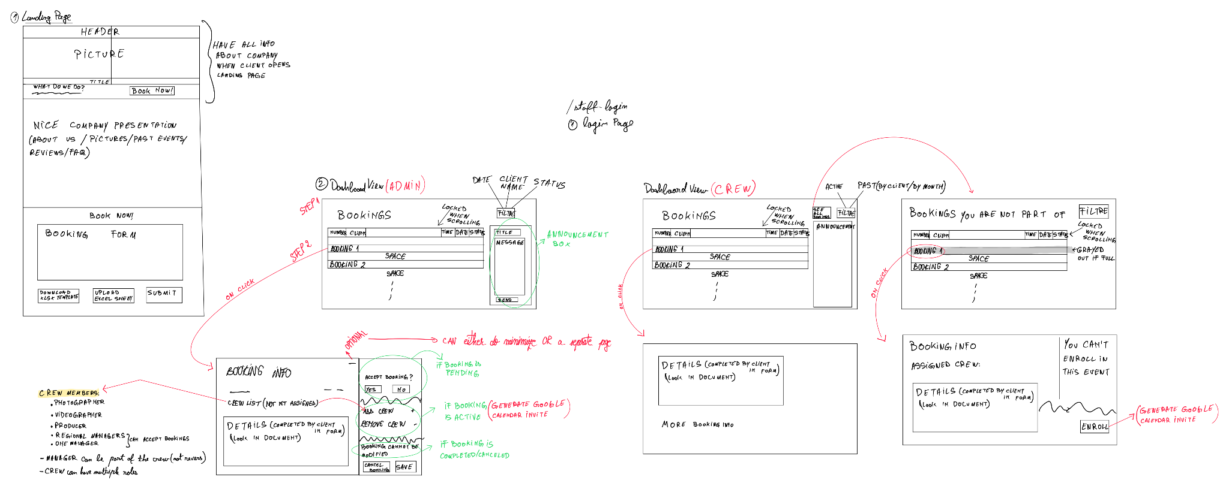

3.2 Database class diagram

The class diagram represents the way in which we will store the information related to client, crew member and their respective relationships to certain events. The database schema will be easily derived from this diagram as all the associations have multiplicity values and therefore, primary and foreign keys will be easily managed.

